**CS 504 – Software Engineering**

**HOP10B – Blazor Application – Deploy to Azure App Service**

12/04/2020 Developed by Kim Nguyen

12/04/2020 Reviewed by Yu-Che Liu

Center for Information Assurance (CIAE) @City University of Seattle (CityU)

**Before You Start**

* Version numbers may not match with the most current version at the time of writing. If given the option to choose between stable release (long-term support) or most recent, please choose the stable release rather than beta-testing version.
* This tutorial targets Windows users and MacOS users.
* There might be subtle discrepancies along the steps. Please use your best judgement while going through this cookbook style tutorial to complete each step.
* For your working directory, use your course number. This tutorial may use a different course number as an example.
* The directory path shown in screenshots may be different from yours.
* If you are not sure what to do or confused with any steps:
  1. Consult the resources listed below.
  2. If you cannot solve the problem after a few tries, ask a TA for help.

**Learning Outcomes**

Students will be able to:

* Deploy to Microsoft Azure App Service

**Resources:**

* Microsoft | ASP .NET - <https://dotnet.microsoft.com/apps/aspnet>

**Preparation:**

**Please move the Blazor App folder from “Module 9” folder to “Module 10”.**

Look for ./test.db file, delete this file. If you do not have this file, Ignore this step:

**Blazor App – Deployment and Continuous Deployment (CI/CD)**

We have been developing our app for 9 weeks, now it’s time to bring it for the world to see. Obviously, we can’t ask clients to download our source code, run the app and go to localhost:5000 to see the production. Thus, we need to deploy it so people can view the app by accessing a public URL.

We can do so by using Azure App Service. (If you have not signed up to an Azure account, go back to HOP10A before proceeding).

**Install Azure Plug-in**

1. In VSCode, open the BlazorApp project folder. On the left side menu, look for the “Extension” tab, search for Azure App Service, click “Install” under the name of the extension:

**[NOTE: Since I have already installed this extension, the above screenshot shows “Uninstall” button under the name of the extension. However, if you do have have this extension installed yet, you should see “Install” button instead.]**

1. After the installation is completed, you should see Azure App Service shows up on the menu (if not, quit and reopen VSCode again):



**Deployment:**

1. Click on the Azure App Service icon, choose Deploy to Web App option:

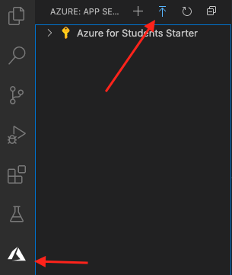

**[NOTE: If you are prompted to login to Azure account, please do so to proceed]**

1. A menu as below will show up, choose the first option (Create new Web App…)

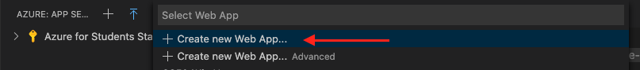

1. Enter “CS504YourFirstNameLastName” into the box, to give your website a name [NOTE: replace YourFirstNameLastName with your actual first and last names], then hit ENTER:

1. Choose .NET Core 3.1 (LTS) option for runtime stack:

1. Extend the Azure for Students Starter tab, you should see your app deployment:

1. Once the deployment is done, go back to the Azure portal home page, click on the burger menu on the top left corner:

1. Click on App Services:

1. You should see the app you just deployed is running:

1. Click on the name of the app, you should see a similar window:

Notice the URL on the screen, that’s the public URL leading to your web application.

1. Click on the URL, your web app should be opened:

Look at your web app’s URL, no more localhost:5000. Congratulations, you have successfully developed and deployed a web application! The world can now see your app by going to that address! ☺

**Required: Take a screenshot of your app running on the URL generated from deploying to Azure. Save the picture in Module 10 folder.**

**Continuous Deployment (CI/CD)**

Now our app is live, what happens if we want to make changes to the app and publish them? Do we have to go through the deployment process again? No! We can automate! Want to know how? Check out HOP10C *(This HOP10C is optional, you are not obligated to complete).*

☺ Hope you enjoyed Full stack development and learned a thing or two! See you in other CityU courses! ☺

**Push your work to GitHub**

Open the terminal from the VSCode by hitting the control + ~ key, make sure you are in the right path, for example: /Desktop/CS504/HOP010-YourGitHubUsername/Module 10

Type the following command:

git add . (to copy all changes you have made)

git commit -m “Submission for Module 10 – Your Name” (To add a message to your submission)

git push origin master (to upload your work to Github)